**Quiz # 01**

1. **Which of the following cannot be used as an Activation Function/Functions? (B, C)**

A) 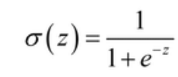 B)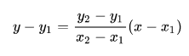

C)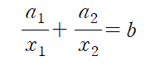 D)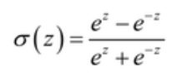

1. **In a circle data problem, why increasing the number of hidden layers doesn’t work? (D)**

A) The solution gets too complicated.

B) The scale grows and even unnecessary factors affect the outcome.

C) The correlation between the data changes in the wrong direction.

D) The correlation between data does not change.

1. **What does a neuron compute? (A)**

A) A neuron computes a linear function followed by an activation function.

B) A neuron computes an activation function followed by a linear function.

C) A neuron computes a function g that scales the input linearly.

D) A neuron computes the mean of all features before applying the output to an activation function.

1. **Which is the best output configuration for a model tasked with classifying a dog’s mood(e.g. happy, sad, hungry etc) by the movement of the tail? (C)**

A) One neuron with linear output

B) One neuron with sigmoid

C) Multiple neurons with softmax

D) Multiple neurons with sigmoid

1. **What is the right word for the blank? (C)**

|  |
| --- |
| The ______ is used as a measure of accuracy to identify whether our neural network has learned the patterns accurately or not with the help of the training data. |

A)Axon hillock

B) Bias

C) Loss function

D) Neuron